**Ethical Hacking Project**

* What is MAC Address
  + **Media Access Control** 
    - Permanent
    - Physical
    - Unique
    - This MAC address is Assigned by Manufacturer
* Why changing the MAC Address?
  + Increase anonymity
  + Impersonate other device such as bypassing filers, connect to network that only specific devices with specific MAC Address can connect. Also, you can able hide your identity
  + How to change MAC address ( **Ether is my mac address on WLan0)**

* + - Ifconfig wlan0 down
* ifconfig wlan0 HW (hardware) **ether 00:11:22: 33:44:55**
* ifconfig wlan0 up

* PACKET SNIFFING: using Airodump-ng
* Part of aircrack-ng suit
* **Airodump-ng** is packet sniffer
* Used to capture all packet within range
* Display detailed info about network around us
* Connected client …etc.: use **Airodump-ng [ monitormodelterface]**
* **How to enable your monitor mode: look at this picture**

* After you enable your monitor mode: you have to use this command line to discover all the wireless networks around your network and displaying useful information about them **: Airodump-ng wlan0mon**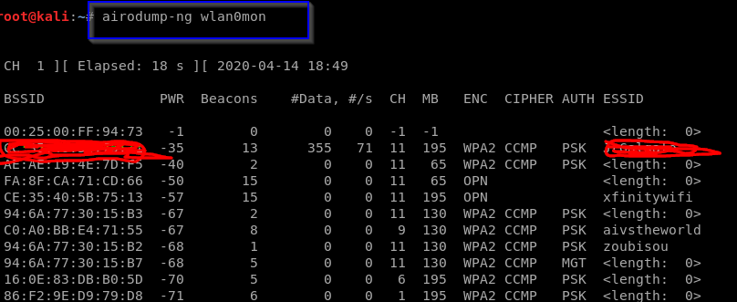

**WIFI BANDS**

* Decides the frequency range that can be used
* Determines the channels that can be used
* Clients’ needs to support band used by router to communicate with it
* Data can be sniffed from a certain band if the wireless adapter used supports that band
  + **MOST COMMON WIFI BANDS ARE** 
    - **A use 5 GHZ frequency only**
    - **B, G both use 2.4 GHZ frequency only**
    - **N uses 5 and 2.4 GHZ**
    - **AC uses frequency lower than 6 GHZ**

**Let try this command line: Airodump-ng wlan0**

* Then you can get wireless around you
* Airodum-ng only sniffing on 2.0 GB frequency

* How to sniff and discovery 5 GB frequency
* By suing this command line: **Airodum-ng –band a wlan0m**
* You can also add more band to capture more data 2.4 and 5 GB at the same time **(Airodump-ng –band ab wlan0mon)** A screenshot of a cell phone

  Description automatically generated

**TARGETED PACKET SNIFFING**

* How to gather more information about the target network
* **Airodum-ng –bashid F8:23:B2:B9:50:A8 –channel 2 –write test wlan0mon**
* This network I sniff **have 4 devices** connected to network and you can see **the MAC address, and** under station you can see different client or device connect to this network

* So, you have to go back to your Linux command line since you saved our date **(--write test)**
* You will you get 4-5 files that you save to get more information about the network that you sniffed **(such as test-01csv, test-01. kismet.netxml, text-01.cap etc. )**
* To get more info about the file use test-01.cap because this file contains chat message, username, and password
* To analyze the date, we must use Wireshark (you will see what type of device is connect to your network

**DE-AUTHENTICATION ATTACK (WIFI)**

* Disconnect any client from any network
  + Works on encrypted network (WEP, WPA AND WPA2)
  + No need to know the network key
  + No need to connect to the network
  + Command line to use to do **DE-AUTHENTICATION** attack : **airplay-ng –death 10** ( how long you need to disconnect this client from the internet **) -a ( the mac address ) – c** ( the client you need to disconnect from the internet ) **wlan0mon**
  + After you run this command you will disconnect all internet from the device (look at the picture

**GAINING ACCESS: WEP CRACKING**

* Wired E equivalent privacy
* Old encryption
* **Uses an algorithm called RC4 (encryption data)**
  + Client encrypts data using a key
  + Encrypted packet sent in the air
  + Router decrypts packet using the key
  + Each packet is encrypt using a unique key stream
  + Random initialization vector (IV) is used to generate the keys streams
  + The IV only 24bits
  + IV + key (password) = key stream
* Still used in some networks
* Can be cracked easily

To creaks WEP we need to use:

* + Capture a larger number of packets / IV. **we are using Airodump-ng**
  + Analyze the captured IV and Crack the key = **using aircrack-ng**
  + So, to capture the date again we have to **run Airodump-ng –bssid (#) –channel 1 –write basic_wep (which is the file we are saving ) and wlan0mon**

* After we run the Airodum to capture the data: which is 66399. We have **run aircrack-ng to capture file (which is basic_wep-01.cap)**
* Then we have found the key which **[ 4173313370 or ASCIIAs23p]** which you can be able to connect to the victim internet

**HOW TO CREATE WORLD LIST**

**WPA /WPA 2 CRACKING**

* The handshake does not contain data helps recover key
* It contains data that can be used to check if a key is valid or not
* Creating word list, you will use Crunch
  + Syntax: > crunch [ min] [ max] [ char] -+ [ pattern] -0 [ Filename]
  + Example > Crunch 6 8 123bc$ -o wordlist -+ a@@@
  + This will be generated passes:
  + To open the file, you create: **cat text.txt**

* If you need to use patter option: you can use this command line:
* **Crunch 6 6 abc12 -o test.txt -t a@@@b**
* The generate number goes lower than the previous one because we used -t

32. **POST-CONNECTION ATTACK**

* Discover all device on the network
* Display their:
  + Ip address
  + MAC address
  + Operating system
  + Open ports
  + Running service
  + We shall use NMAP and netdiscover

**Check how man device is connect to your Wi-Fi**

* Example is: **netdiscover** -r 10.0.2.1/24
* Connect your wireless adapter to see how many networks is connect to your device in real world
* This are the people / client that are connect to my network device my using **netdiscover**

* how to check wlan0 to see how many clients is connect to this Wi-Fi by using the same command line
* you see all the info about the client info on the pc

**Man-In the middle attacks**

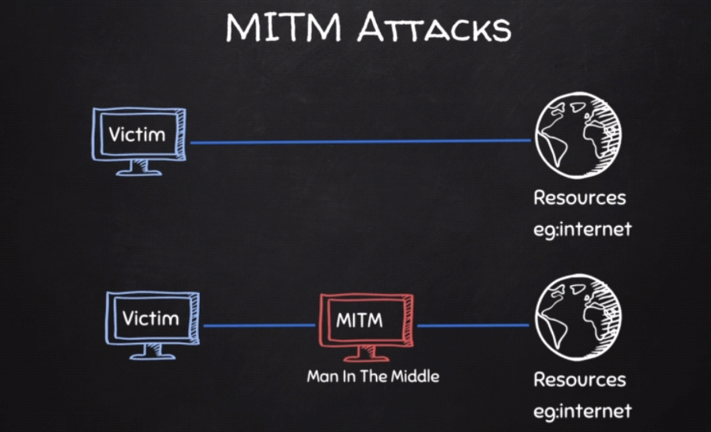

**What is ARP: Address Resolution Protocol**

* Simple protocol uses to map IP address of a machine to its MAC address

Examples of ARP on kali Linux and Windows

* Just type ARP – a **in kali Linux terminal**: you will get this result: _gateway (10.0.2.2 )

**Windows ARP**

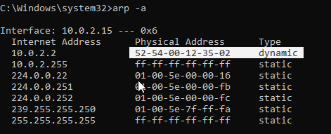

Using ARP Spoofing

**: using ARPSPOOF**

* Arpspoof tool to run arp spoofing attacks
* Simple and reliable
* Ported to most operating systems including Android and iOS
* Usage is always the same

Use:

. arpspoof -I [ interface] -t [ client IP ] [ gateway IP]

. arpspoof -I [ interface ] -t [ gateway IP ] [ client IP ]

**Using Better Cap:**

* **Framework to run network attack**
* **Can be used to:**
* ARP Spoof target (redirect the flow of packets)
* Sniff data (URLs, username passwords)
* Bypass HTTPs
* Redirect domain request (DNS spoofing)
* Inject code in loaded pages and more
* Use: battercap -iface ( interface ) > install bettercap in kali Linux : apt-get install bettercap
* Click help to see what you need
* How to check client to connected to the same network **( by doing net. Probe on )**

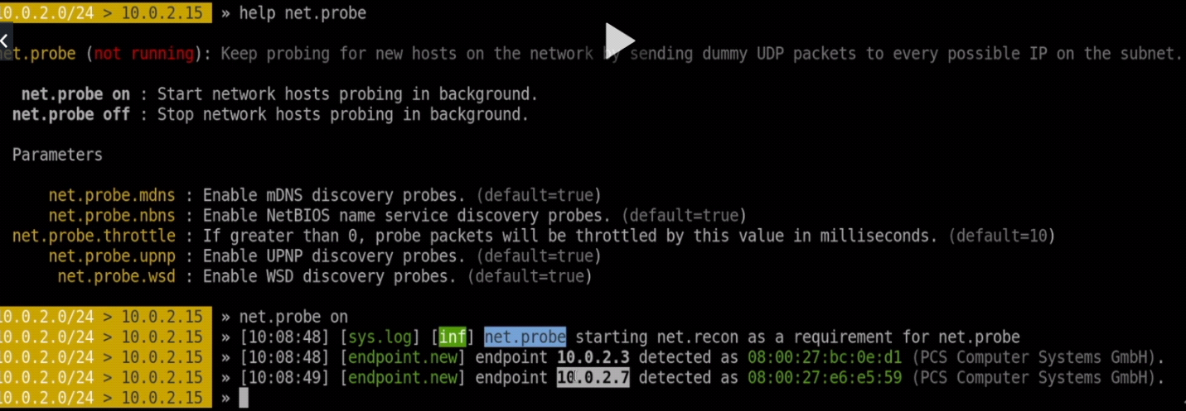

**How to see if the client is connected to the network:**

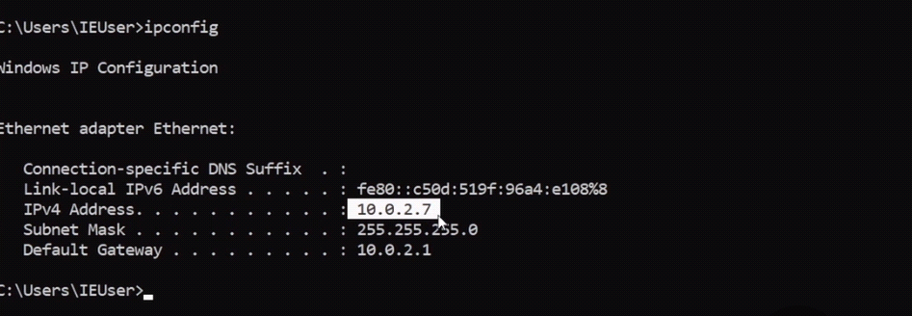

**To get more information about the client details type net.show**

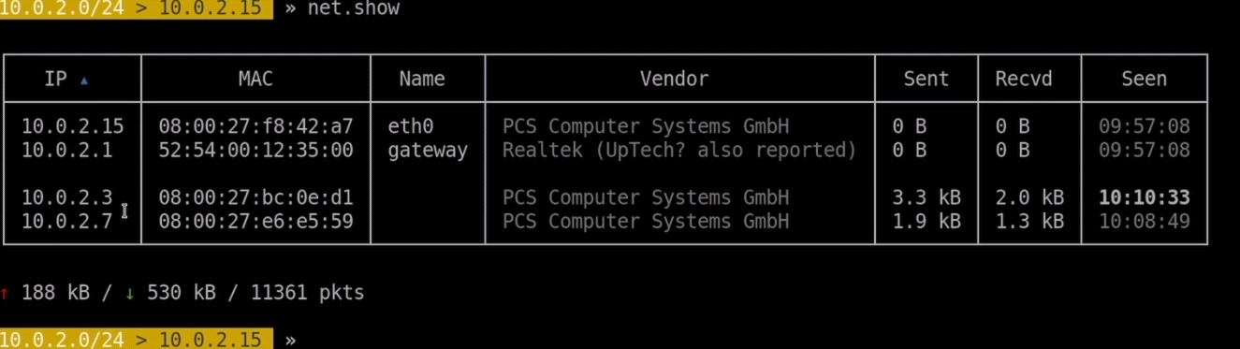

Using Arpspoof using bettercap to access more information **such as password, login**

* You need to Turn on net. Probe. net. recon **by typing help-**

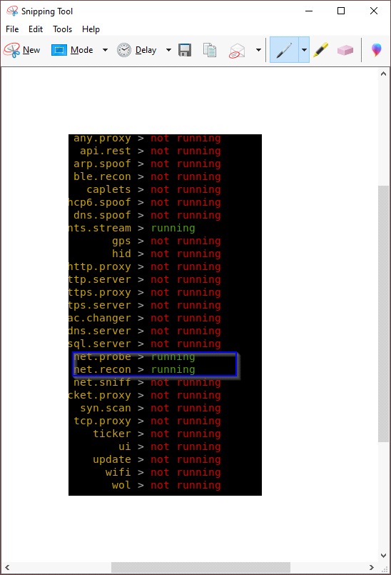

To get more info about the man-the middle you need to do **arp. Spoof**

* We must modify the option they give as with yellow colors

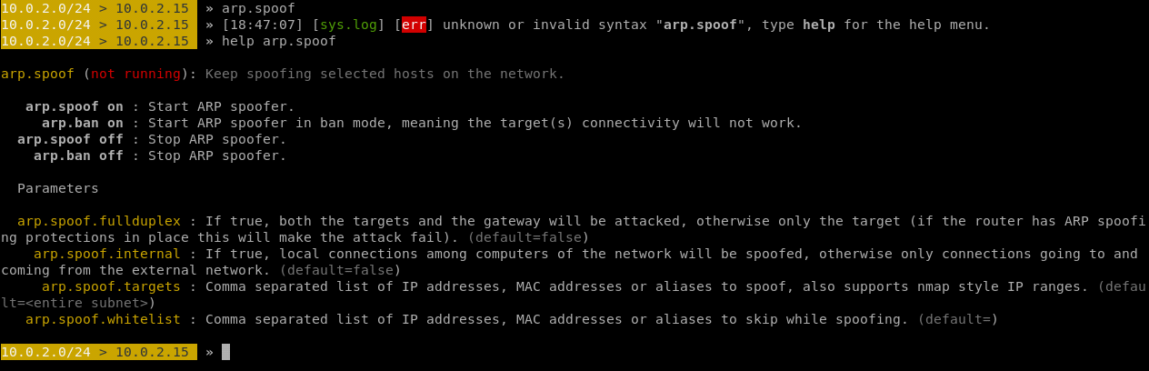

* To change the modify: **set** **arp. spoof.fullduplex** (value ) change to **true**
* Change the target that you need to run against: **set arp.spoof.targets** (value) IP against my target: which are windows **(10.0.2.15)**
* **So, we must** turn on the **arp. Spoof (look at the picture)**
* All the information on windows such as password login will go thru kali Linux since we did man in the middle

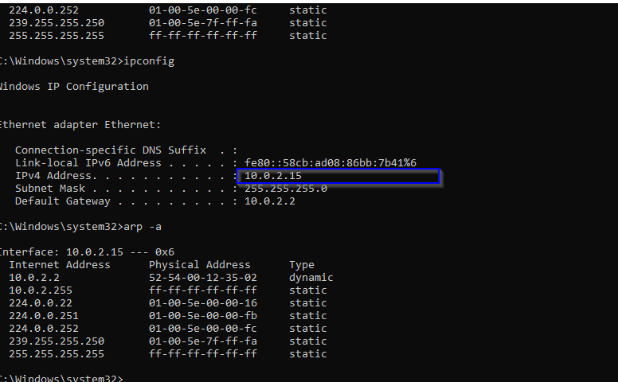

* As you can see both IP address of windows and kali are the same
* Anything you are doing at windows such visiting website or login, kail will capture it

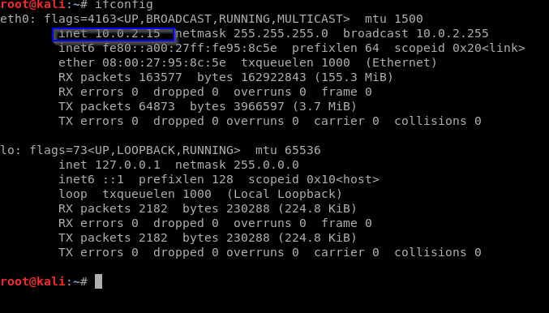

**To capture all data: we will use net. niff ( on )**

* Everything on windows will be capture since we are not using any website that have https
* After we turn on the sniff: we capture the login and the password on the website we visited

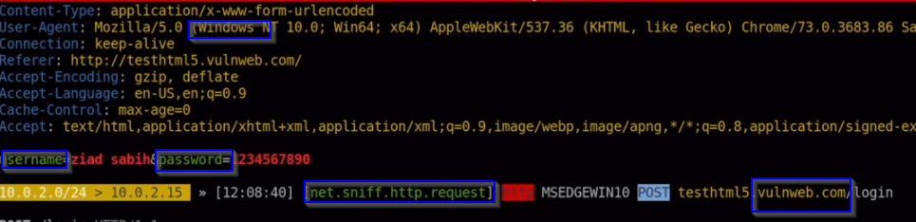

OWAZED Attack proxy ZAP

* Automatically find vulnerabilities in web application
* Free and easy to use
* Can also be sued for manual testing
* Something ZAP can give you a false alarm
* 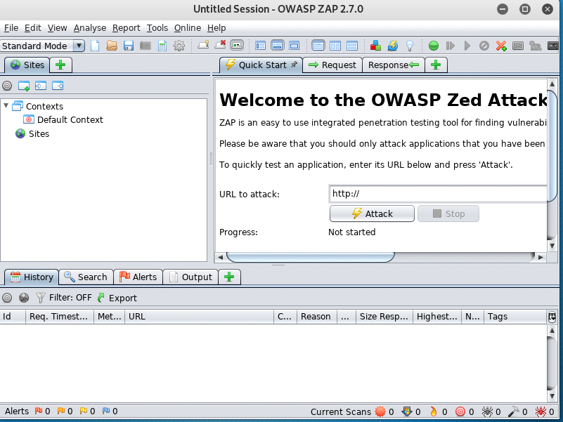
* After we open OWASP Zap, we know target a website
* Practices website: go to google dork its open source for everyone
* Look at the results on the picture after we did the target (look **at the alert and the context)**
* You can get more information by click alert and contexts

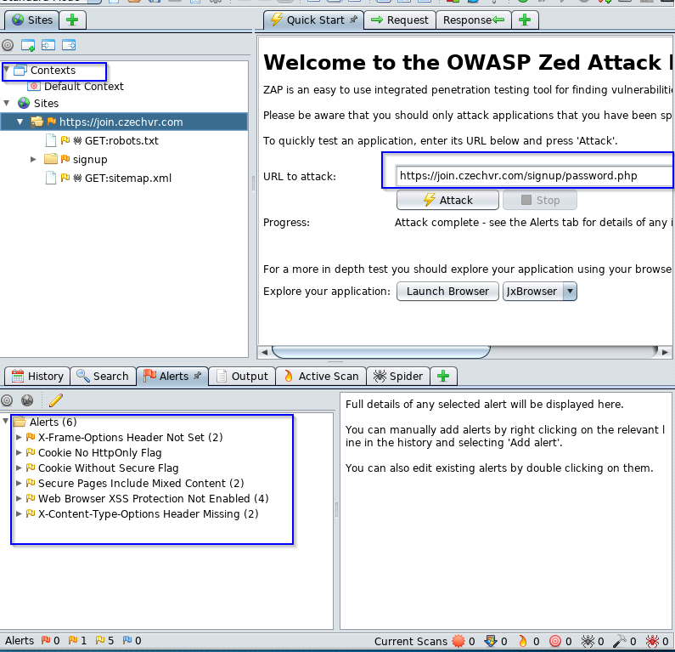

* By attack this website we found 6 which are **red is high alert, orange medium alert and yellow low alert**
* You can see the red is 0 thread and the rest have number of threads

